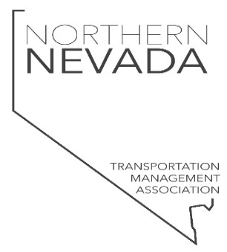

WHO
The Northern Nevada Transportation Management Association (Northern Nevada TMA) is an established association of interested and vested businesses working collaboratively on the current and future transportation strategy for the Northern Nevada market.

WHAT
We are dedicated to making a collective impact on traffic reduction, reviewing future transportation plans, implementing a broad-based communication protocol and being a source of information for our commuter population, as well as the community at large.

WHY
Northern Nevada has seen a huge population growth, has been named by several sources as the fastest growing area in America, and is projected to continue to significantly outpace the rest of the US in job growth over the next 10 years. With this growth comes increasing pressure on the transportation infrastructure that is already presenting challenges at the TRI-Center. Our goal is to have representatives from businesses in the area join forces to eliminate transportation as a barrier to talent acquisition and retention, operations, and safety.

How does this impact your business?
With the significant growth of Northern Nevada, the partners of the TMA recognize the gap in transportation services to, from, and within the Reno Tahoe Industrial Center. Our association understands that this gap greatly impacts your business’ workforce dependability and retention. Our goal is to proactively provide input, planning, innovation, collaboration, and professional experience resulting in transportation alignment for long-term workforce sustainability in your business operations!

Current Representation
- Economic Development Authority of Western Nevada (EDAWN)
- COMMUTE with Enterprise
- My Ride to Work
- RTC
- Storey County
- NDOT
- Kimley Horn

WHAT’S NEXT
Quarterly meetings with an established agenda
Action items and community involvement

